Lesson 2 Demo 1
Execute Basic Linux Commands

Objective: To execute the basic Linux commands.

Tools required: Ubuntu, Terminal

Pre-requisites: None

Steps to be followed:
- Executing basic Linux commands.

Step 1: Executing basic Linux commands
- List the files or folders present in the current directory.
ls
- Create a new directory in the current folder, and check if the folder is created.
mkdir New_Folder
ls
- Navigate to the New_Folder directory by changing the current directory.
cd New_Folder
- Write some text in a demo file, and display the content of the file
echo "This is a demo file" > demo.txt
cat demo.txt
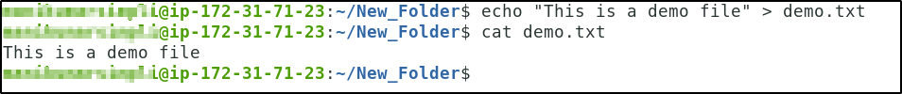
- Change the mode of the demo.txt file to read only
chmod -r demo.txt
- Remove the demo.txt file from the folder, and list the files in the folder
rm demo.txt
- Change the current user as a super/root user
sudo su

- Install git using the apt-get package manager
apt-get install git
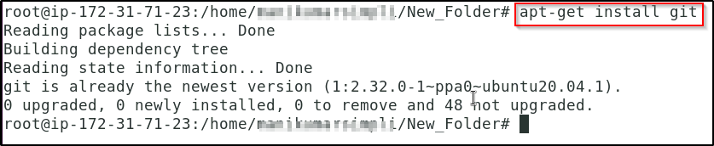
- List all the previously used commands
history
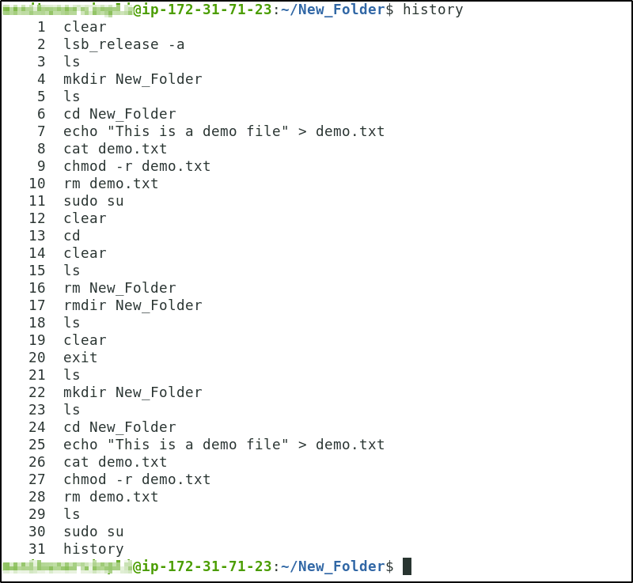
- Clear the Terminal screen.
clear


1.11 Creating a file using vi.
vi <filename>.<extension>
For ex: vi test.txt
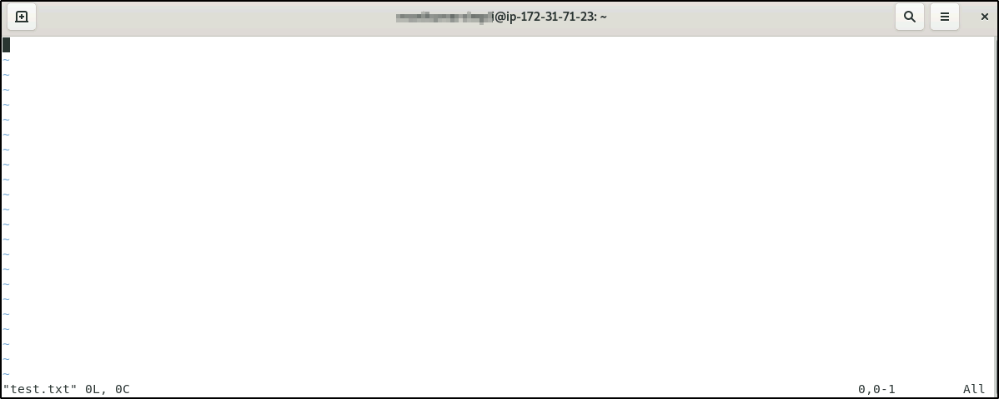
1.12 Changing file permissions.
chmod <permission code> <filename>.<extension>
For ex: chmod 777 test.txt
1.13 Unzipping a file.
tar -xf <filename>.tar.gz
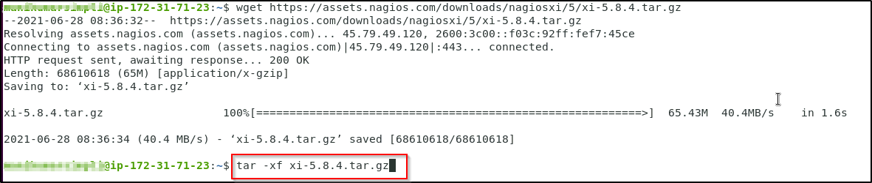
unzip <filename>.zip
